CT3680 Automated Testing Platform

Emma Gostling

CST-451/452 Capstone Project Proposal

Grand Canyon University

Instructors: Bradley Mauger, Amr Elchouemi

Revision: 2.0

Date: 26 November, 2025

**ABSTRACT**

The CT3680 is an audio delay module developed by Cabintech Global LLC, which takes audio input and manipulates it to create various audio effects. It is typically used in musical equipment such as guitar pedals and synthesizers. Cabintech currently tests each of its modules manually prior to shipping to customers to make sure the hardware works correctly. This process takes a significant amount of time. This is acceptable when the quantities being tested are small, however, as the popularity of this delay module continues to grow, more efficient methods of testing need to be developed in order to keep up with market demands.

All of the tests that are currently done manually are capable of being detected programmatically. As such, the proposed solution is to develop a system by which these tests can be automated, saving a significant amount of time when it comes to checking each of the modules for physical defects. This will involve the development of both hardware and software, which will work together to verify that all electrical signals are passing through the module as expected. The software will also communicate with various back-office systems, such as the stock management system, in order to make sure that they stay up to date.

|  |
| --- |
| History and Signoff Sheet |

**Change Record**

|  |  |  |
| --- | --- | --- |
| **Date** | **Author** | **Revision Notes** |
| 20 July 2025 | Emma Gostling | Initial draft for review/discussion |
| 26 November 2025 | Emma Gostling | Final updates reflecting the results of the project, changes include updating tables with actual time and cost values |
|  |  |  |

|  |
| --- |
| **Overall Instructor Feedback/Comments** |

|  |
| --- |
| **Overall Instructor Feedback/Comments** |

**Integrated Instructor Feedback into Project Documentation**

Yes  No

**Project Approval**

Professor Mark Reha

**TABLE OF CONTENTS**

Project Overview and Project Objectives 4

Project Scope 7

Project Success Measures 8

Project High-Level Solution 9

Project Controls 10

Project Cost and Schedule 12

Cost Spreadsheet 12

Appendix A – References 14

Appendix B – Copyright Compliance 15

Project Overview and Project Objectives

**Background**

The [CT3680](https://d.docs.live.net/fda233dd99ad3b90/Documents/School/GCU/CST451/cabintechglobal.com/ct3680) is an audio delay module developed by [Cabintech Global LLC](https://d.docs.live.net/fda233dd99ad3b90/Documents/School/GCU/CST451/cabintechglobal.com), which takes audio input and manipulates it to create various audio effects. This module is an “embedded system” that contains a specialized processor (Digital Signal Processor (DSP)), several digital-to-analog and analog-to-digital converters, a power regulator, and various logic chips. Firmware (code) runs in the DSP to implement various signal processing functions related to audio delay effects such as echo, reverb, chorus, and many others. This module is typically used by Cabintech customers in musical equipment such as guitar pedals, synthesizers and recording studio equipment.

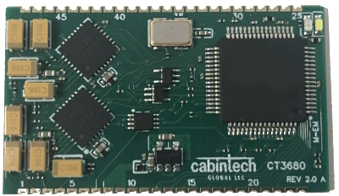

Figure . CT3680 Delay Module

All testing is currently done manually using a purpose designed test fixture, and takes a significant amount of time and skill to insert and run the various tests. There are currently over 20 different steps in the manual test process. For small orders this is manageable, however when customers order larger quantities, testing time can quickly become excessive. Additionally, the test fixture itself is quite fragile and involves spring-loaded pins which tend to get stuck and require some manipulation in order to make a reliable connection with the module.

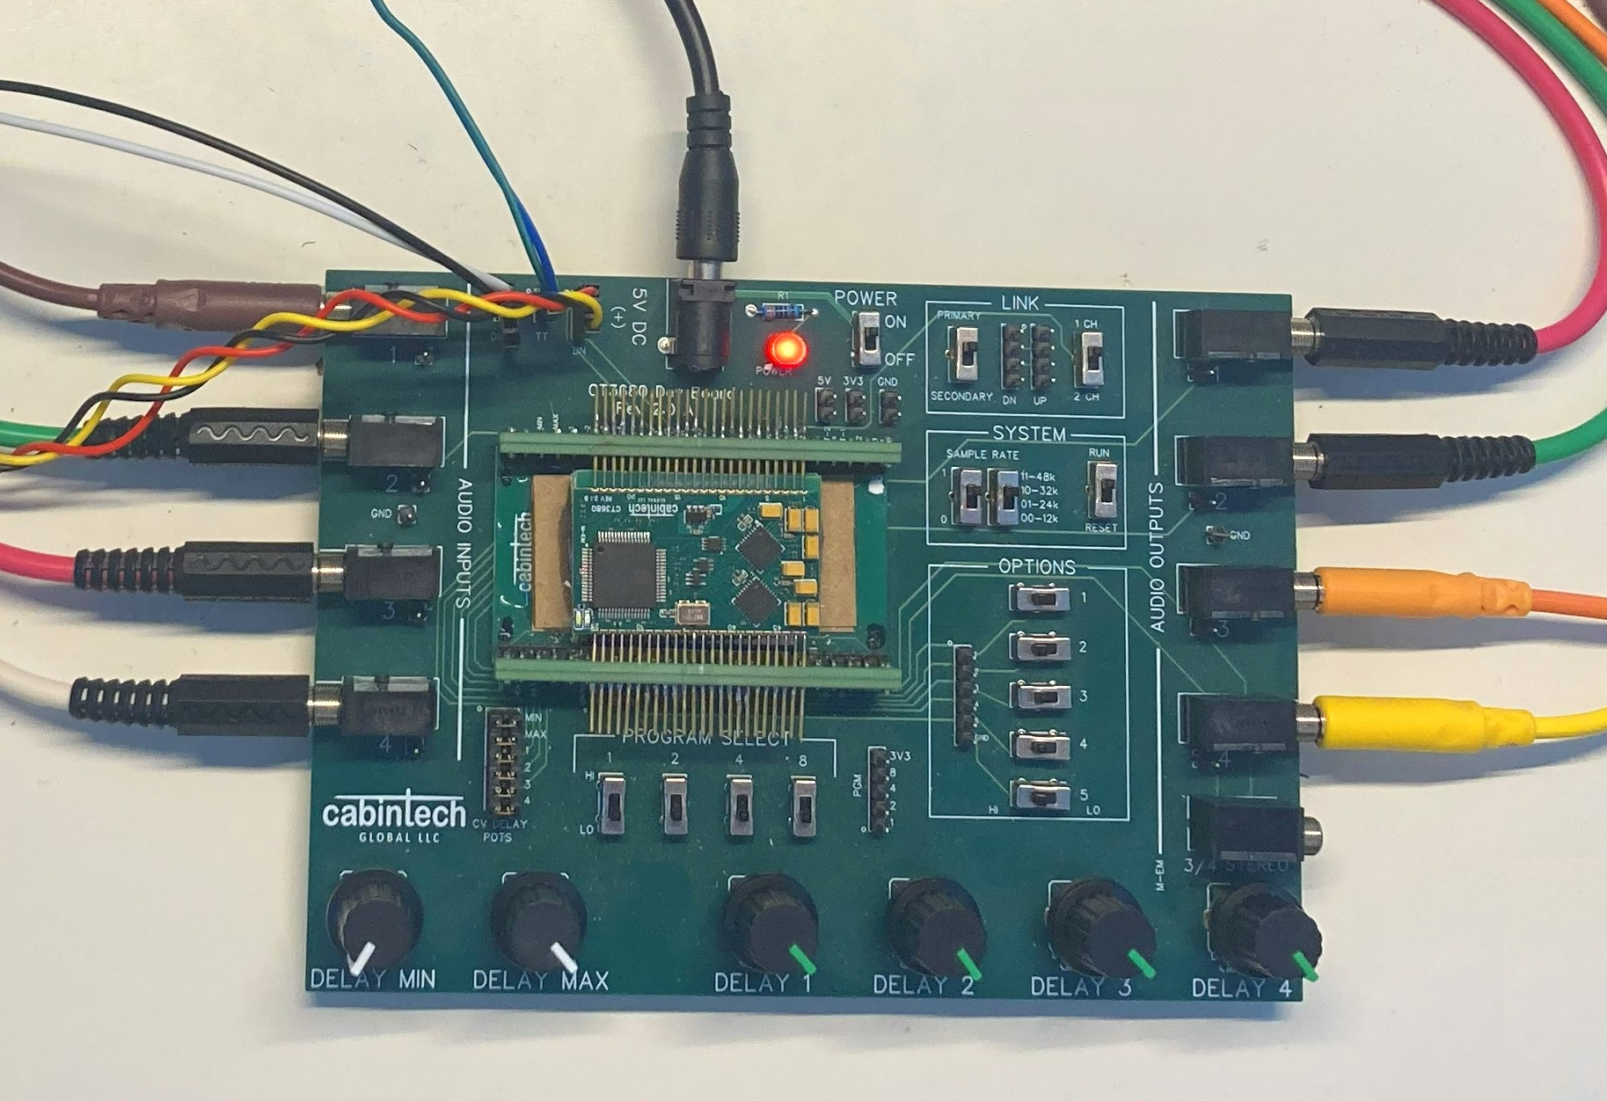

Figure . Current Manual Test Fixture

Manual testing also introduces opportunities to overlook defects. This project intends to automate these procedures, creating an updated and more reliable test fixture that is integrated with testing software, ensuring that all tests are run reliably on each of the modules with far less time and effort.

**Christian Worldview**

As Christians we are called to approach our work in an ethical and responsible manner, regardless of whether such work is directly Christian in nature. While hardware and software development may seem entirely unrelated to Christianity, there are still ethical principles that can be applied in the field and to any project. In many cases this may include adhering to best security practices when developing software. In the context of this project, security is less of a concern, as the testing platform (both hardware and software) will be for internal company use only. That said, building reasonable security measures into it is still good practice. Christians have a responsibility to give their best efforts in everything they do. This means committing fully to the project and building the best quality into it as possible. By building quality into our testing system, we help to ensure the quality of the products we are testing, therefore making sure that our customers receive good, reliable products.

**Project Objectives**

**Hardware:**

1. Develop an easy-to-use mechanical system for inserting and removing modules from the test fixture
   1. Must make reliable connections with all pins
   2. Should be able to insert or remove a module within 5 seconds
   3. Insert and removal must not damage the module or fixture
2. Develop a testing platform consisting of a printed circuit board with all of the physical components necessary to make automated testing possible.

**Software:**

1. Achieve automation of all testing steps for the delay module
2. User interface for reviewing test results
3. Automatic increment of stock count and entry of all passing modules’ serial numbers into the registration table

**Challenges**

The biggest challenge in completing this project will be learning the various technologies required. These may include:

* 3D design and printing
* Microcontroller programming
* Hardware test procedures
* Understanding manufacturing defects
* Analog/digital control
* System API’s for stock management and test data
* System integration (hardware, software, IT systems, etc.)

Mentorship in these areas will be provided by Cabintech in order to address skill gaps in specific technologies necessary for project completion. Additionally, hardware design will be handled by Cabintech engineers.

**Benefits and Opportunities**

The primary benefit resulting from the successful completion of this project will be a significant increase in efficiency when it comes to testing and processing new hardware deliveries, saving the company considerable time and effort. This would also allow the company to scale up its capacity. All modules must be tested prior to being shipped to customers. Current testing methods would require two full weeks to test and process an incoming shipment of 1000 pieces. To keep up with larger orders, this processing time needs to be reduced.

Additionally, automated testing will increase confidence in the quality of the product by reducing the potential to overlook any defects. By automating the testing process, the possibility of human error is reduced, ensuring that none of the testing steps are missed or rushed through.

This platform may also serve as a basis for future development, extending beyond the testing of the hardware itself, possibly adding functional and regression testing capability for the modules to verify that the firmware programmed into them behaves correctly.

Project Scope

The scope of the project will encompass the development of firmware that runs the prescribed tests to verify that the hardware works as expected and detect any manufacturing defects in the CT3680 audio delay module. It will also include the design of an interface for viewing test results as well as integration with the company’s stock management system.

Additionally, it will include the development of the testing system hardware, by which the tests will be run on each of the modules. This will consist of a printed circuit board, containing a microcontroller and various other hardware components necessary to carry out testing.

The project will not include the packaging, labeling or preparation of modules. Testing of the firmware that is programmed into each of the modules is also out of scope for this project.

**Stakeholders**

|  |  |  |
| --- | --- | --- |
| Stakeholder Name | Role(s) | Responsibilities |
| Self | Primary Developer | Code development, hardware development, system integration |
| Development Manager | Project and Technical Management | Project approval, schedule management, cost management, code review, technical mentoring |
| Sales Manager | Sales and Marketing | Project review and approval |

1. List the work breakdown required to satisfy the project objectives. Identify teams and other resources that may be required to successfully complete the project.

|  |  |  |  |  |  |  |  |  |  |
| --- | --- | --- | --- | --- | --- | --- | --- | --- | --- |
| Work Breakdown Structure | | | | | | | | | |
| ID | Task | Dependencies | Status | Effort Hours | Cost | Start Date | Planned Completion | Estimate to Completion | Actual Completion |
| 1 | System Architecture |  | Completed | 20 hr | 0 | 7/21 | 7/27 | 20 hr | 21hr |
| 2 | Hardware design decisions (Proof-of-Concepts) | Task 1 | Completed | 40 hr | 0 | 7/28 | 8/24 | 40 hr | 28hr |
| 3 | Test fixture design |  | Completed | 40 hr | $50 | 7/28 | 8/10 | 40 hr | 51hr |
| 4 | Firmware design for microcontroller | Task 2 | Completed | 40 hr | 0 | 8/25 | 9/7 | 40 hr | 31hr |
| 5 | Software design for PC | Task 1 | Completed | 20 hr | 0 | 9/8 | 9/14 | 20 hr | 34hr |
| 6 | PCB design | Task 2 | Completed | 20 hr | 0 | 9/15 | 9/21 | 20 hr | 12hr |
| 7 | PCB production | Task 6 | Completed | 20 hr | $100 | 9/22 | 9/28 | 20 hr | 2hr |
| 8 | Parts sourcing | Task 6 | Completed | 10 hr | $200 | 9/29 | 10/5 | 10 hr | 2hr |
| 9 | Assembly | Task 7,8 | Completed | 10 hr | $25 | 9/29 | 10/5 | 10 hr | 6hr |
| 10 | Hardware debugging | Task 9 | Completed | 10 hr | 0 | 10/6 | 10/12 | 10 hr | 15hr |
| 11 | Microprocessor integration | Task 9,4 | Completed | 15 hr | 0 | 10/6 | 10/12 | 15 hr | 6hr |
| 12 | System testing | Task 11 | Completed | 15 hr | 0 | 10/6 | 10/12 | 15 hr | 12hr |
| 13 | Verification Testing | Task 12 | Completed | 20 hr | 0 | 10/13 | 10/19 | 20 hr | 22hr |
| 14 | Overall system integration | Task 11 | Completed | 10 hr | 0 | 10/20 | 10/26 | 10 hr | 5hr |
| 15 | Acceptance Testing | Task 11 | Completed | 10 hr | 0 | 10/20 | 10/26 | 10 hr | 6hr |

Project Success Measures

In order for this project to be considered successful, it will be completed on time and within budget. Additionally, the amount of time it takes to test each module must be significantly reduced. The goal is to reduce test times by at least 50%, allowing the company to keep up with market demands. The hardware and software developed over the course of the project must be robust and reliable and must meet all of the objectives listed above, providing for quick and reliable insert, testing and removal of modules without risk of damage. It must automate all manual tests and provide a platform for review and approval, as well as automatic entry of all approved modules into the stock management system.

1. Use the template to list the project completion criteria.

|  |
| --- |
| Project Completion Criteria |
| 1 – The test fixture makes reliable connections with all module pins |
| 2 – Modules can be quickly inserted and removed from the test fixture |
| 3 – The insertion and removal of modules is safe and does not risk damage to the module |
| 4 – All tests that were previously done manually are automated |
| 5 – All test results are recorded and sent to the IT system for review |
| 6 – There is a user interface that allows for the review of test results |
| 7 – The serial numbers for all modules that pass the testing stage are entered into the stock management system |

1. Use the template to list the project assumptions and constraints, if applicable. An assumption is an educated guess that a likely condition or circumstance is presumed to be true. A constraint is a limiting condition or circumstance that defines the project boundaries. Assumptions allow the project to succeed. Constraints restrict or limit the project execution.

|  |  |  |  |  |  |
| --- | --- | --- | --- | --- | --- |
| Assumptions and Constraints | | | | | |
| ID | Description | Comments | Type | Status | Date Entered |
| 1 | The company will provide all resources and equipment needed for the project | This will include things such as circuit board design and manufacturing, 3D printing, assembly equipment, access to back-office systems and mentoring in embedded systems | Assumption | N/A | 7/20/2025 |
| 2 | The design of the module is fixed and cannot be modified to meet testing needs. | The CT3680 is in production and modifying it is therefore not an option. The test system will need to work with the existing module design. | Constraint | N/A | 7/20/2025 |
| 3 | Backend systems are largely fixed. | This includes systems such as product registration and stock management. Some minor modifications may be possible, however the test system will primarily need to work with these other systems as they are. | Constraint | N/A | 7/20/2025 |

Project High-Level Solution

**Introduction**

This project will address efforts towards better efficiency for the testing of the CT3680 audio delay module. The project aims to test the correct functioning of the hardware, ensuring that there are no physical manufacturing defects prior to shipping these modules to customers. Examples of possible defects include:

* solder bridges which short-circuit the various electrical wiring together, causing the module to malfunction
* open circuits, meaning that pieces which are supposed to be connected to each other are not.
* defective or missing components, meaning that an individual piece of the circuit does not work correctly or is missing from the assembly.

Currently, testing for all manufacturing defects is done manually, which requires a significant amount of time and skill. Current testing procedures are not scalable to accommodate larger sized orders, and there is therefore a need to develop more efficient means of achieving these checks.

**Solution**

The proposed solution is to develop a test system that is fully automated and can detect these physical defects programmatically. This will include both additional hardware which the module can be placed in for testing as well as software that will run the tests. It will also include a system for reviewing test results. All modules are programmed during manufacturing with a unique serial number, which upon passing all of the physical checks, is then read from the module and entered into the stock management system.

Project Controls

1. Use the template to define the risk and list the steps to prevent the risk from occurring or the steps to minimize the chances of it happening. The contingency plan describes alternative solutions to reduce the impact of the risk. An example of a contingency plan is to provide the customer a temporary web server if there are delays in delivery/completion. If the risk has already happened then provide an entry in the issue log.

|  |  |  |  |  |
| --- | --- | --- | --- | --- |
| Risk Management | | | | |
|  | **Risk Probability** | **Risk Impact** |  |  |
| **Event Risk** | **(high, medium, low)** | **Risk Mitigation** | **Contingency Plan** |
| Hardware production is delayed | Low | Schedule delay | Seek alternate suppliers | Continue using manual testing methods until issue is resolved |
| Tarriff increases cause budget overrun | Medium | Budget exceeded | Find US vendors when possible | Request budget increase |

|  |  |  |  |  |  |  |  |  |
| --- | --- | --- | --- | --- | --- | --- | --- | --- |
| Issues Log | | | | | | | | |
| **ID** | **Description** | **Project Impact** | **Action Plan/Resolution** | **Owner** | **Importance** | **Date Entered** | **Date to Review** | **Date Resolved** |
|  | What is the issue? | How will this impact scope, schedule & cost? | How do you intend to deal with this issue? | Who manages this issue? |  |  |  |  |
| 1 | No current issues |  |  |  |  |  |  |  |

**Changes**

|  |  |  |  |  |  |  |  |  |  |
| --- | --- | --- | --- | --- | --- | --- | --- | --- | --- |
| Change Control Log | | | | | | | | | |
| **ID** | **Change Description** | **Priority** | **Originator** | **Date Entered** | **Date Assigned** | **Evaluator** | **Status** | **Date of Decision** | **Included in Rev. #** |
| 1 | No current changes |  |  |  |  |  |  |  |  |

**End Users Involved in Development**

|  |  |  |
| --- | --- | --- |
| Roles and Responsibilities | | |
| Name | Project Role | Responsibility |
| Self | Developer/User | Module testing |
| Mark McMillan, Cabintech Global | Project Manager | Project scope, schedule, budget, approval, reviews |

Project Cost and Schedule

Cost Spreadsheet

**Project Schedule**

|  |  |  |  |
| --- | --- | --- | --- |
|  | Task | Start Date | End Date |
| 1 | System Architecture | 7/21 | 7/27 |
| 2 | Hardware design decisions (Proof-of-Concepts) | 7/28 | 8/24 |
| 3 | Test fixture design | 7/28 | 8/17 |
| 4 | Firmware design for microcontroller | 8/25 | 9/14 |
| 5 | Software design for PC | 9/15 | 9/28 |
| 6 | PCB design | 9/29 | 10/5 |
| 7 | PCB production | 10/6 | 10/19 |
| 8 | Parts sourcing | 10/20 | 10/26 |
| 9 | Assembly | 10/20 | 10/26 |
| 10 | Hardware debugging | 10/27 | 11/2 |
| 11 | Microprocessor integration | 11/3 | 11/9 |
| 12 | System testing | 11/3 | 11/9 |
| 13 | Verification Testing | 11/3 | 11/9 |
| 14 | Overall system integration | 11/10 | 11/16 |
| 15 | Acceptance Testing | 11/10 | 11/16 |

**Programming Schedule**

|  |  |  |  |  |
| --- | --- | --- | --- | --- |
|  | Task | Time Estimate | Start Date | End Date |
| 4 | Firmware design for microcontroller | 40 hr | 8/25 | 9/14 |
| 5 | Software design for PC | 20 hr | 9/15 | 9/28 |
| 11 | Microprocessor integration | 15 hr | 11/3 | 11/9 |
| 12 | System testing | 15 hr | 11/3 | 11/9 |
| 13 | Verification Testing | 20 hr | 11/3 | 11/9 |
| 14 | Overall system integration | 10 hr | 11/10 | 11/16 |

Appendix A – References

*Cabintech Global LLC.* Cabintech Global. (n.d.). https://Cabintechglobal.com/

*FXCore*. FXCore | Audio Effects DSP | by Experimental Noize. (n.d.). https://www.experimentalnoize.com/product_FXCore.php

Appendix B – Copyright Compliance

No external code currently in use.